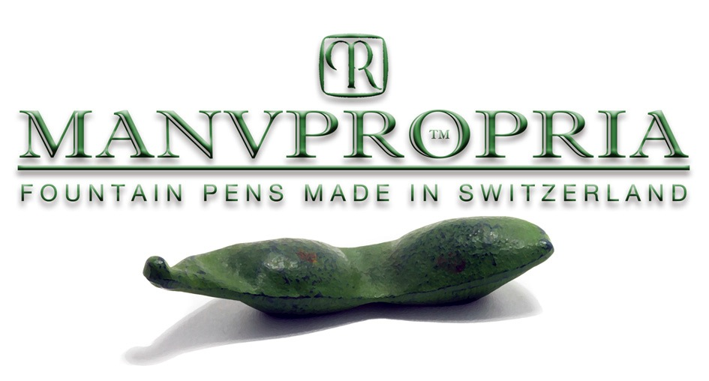

How to order your personal Manu Propria Fountain Pen and what we need to know

You will not find any “Shopping Cart” on this website. Orders are processed directly between the customer and me. The majority of the sold Manu Propria Pens are customized.

Chose your Pen Type and Size
You can find an overview on the different pen designs and sizes in the
"COLLECTION". If you need some modifications don’t hesitate to let us know.

Chose your Urushi Lacquer
Today Manu Propria Pens applies over 100 different lacquers.
For a better overview, the Catalogues are structured according to Lacquer Categories:

• Negoro (Black & Red Lacquer)
• Kawari-Nuri (Experimental Lacquer)
• Ishime-ji (Stone Surfaces)
• Kinsoku Mitateai (Metal surfaces)
• Raden (Mother of Pearl)
• Susutake (Bamboo)

In the LIBRARY you can download the E-Catalogues of the various lacquers.

Chose your Nib
Manu Propria Pens write with 14/18 kt. Gold nibs, standard nib finish EF-F-M-B. All nibs are hand polished before delivery. If you wish an individualized nib, please let us know. we can grind any style of nib finish. We offer Nibs in Yellow, Rose and red Gold Color and Rhodium Plated

The Way you Write
For being able to finish your nib best possible please let us know about

• Writing Pressure: Heavy, Moderate, Light
• Part of Pen Section you hold: Close to nib, Midway, far from Nib
• Writing Speed: Fast, Medium, Slow
• Writing Size: Large, Medium, Small
• Hand you Write with: Left Hand, Right Hand

Prices and Conditions
The Payment is made by order by Bank-Transfer.
In the Library you can download the price Lists with the official retail prices rendered in CHF (Swiss Franks). The price lists are structured according to the Pen Design

Production Time
The production Time of a Uruhi Lacquer Pen takes between 30 and 40 days. The average delivery Time is 45 Days

Delivery, Shipment

We ship our pens with SwissPost registered mail, the shipment is free for you. If you prefer your pen to be delivered by DHL the cost is CHF 135.-

During the progress of a custom project, I will work with you closely from start to finish in every aspect, from design, over selection of urushi lacquer to Nib finishing. To inquire about your pen project, please contact me by email info@manupropria-pens.ch

Sincerely Yours,
Martin Pauli

